
Draft SLA

Service Standard | Project specific Service Level Agreement
Acknowledgement of requests | Translation or other requests via e-mail will be promptly acknowledged upon receipt. Receipt of an approved client brief via i plus or e-mail with a translation or other language request becomes the key activation point for requested translation and adaptation and the establishment of a translation or language project plan.
Translation service | All translators will translate into their native language, and demonstrate an appropriate qualification in both subject specialism and linguistic expertise and at least 5 years of relevant translation experience.
Turnaround time | Delivery deadlines will be agreed between translate plus and client on a case by case basis and respecting client’s wishes and requirements as much as possible. Once agreed between the parties, the delivery deadline will be met. As a guideline, client users may wish to refer to the following indicative timelines using one linguist per task:  Standard human translation requests:  Next day deliveries (24 hours): 500 – 1,000 words  48 hours (2 working days): 1,001 – 2,500 words  72 hours (3 working days): 2,501 – 4,500 words  96 hours (4 working days): 4,501 – 6,500 words  120 hours (5 working days): 6,501 – 8,500 words  Machine translation projects without post-editing:  Within minutes once an automation with our TMS i plus has been set up.  Machine translation projects with standard post-editing in line with ISO 18587:  Same or next day deliveries (24 hours): - 2,000 words  48 hours (2 working days): - 4,500 words  72 hours (3 working days): - 8,500 words  The use of CAT tools, i.e. translation memory technology, can help reduce the above-mentioned turnaround times and also helps to improve linguistic consistency across multiple files/assets or previously translated content. We can very often easily up- and down-scale our resources and take our client’s timings into consideration. translate plus will establish preferred translators for each client and business unit and allocate translation projects to those in the first instance. Should all of the preferred translators be unable to perform the task within the agreed timeframe, translate plus can notify client (if you so wish) and confirm whether they are allowed to involve another qualified translator (or allocate the task to another qualified linguist without waiting for feedback from client). We can also involve more than one translator or editor in the task to speed up turnaround times and seek to automate translation workflows where possible so that our linguists can start working on their projects faster, which aids the overall processing times. Please note that different turnaround times may apply to out-of-scope or more complex requests or projects that are subject to a different translation workflow, e.g. sworn, regulatory and patent translations. If you would like to discuss alternative turnaround times, please do not hesitate to get in touch.
Quality standards | Errors are defined as follows:  - Spelling and typos: misspelling of individual words, including the use of accents; inappropriate use of punctuation; mistakes in the DTP process leading to missing or extra letters, punctuation marks, accents etc.  - Grammatical mistakes: gender agreement, use of verb tenses, singular and plural endings etc.; syntax – incorrect word order etc.  - Other linguistic errors: inappropriate use of language; inappropriate tone/style where this deviates significantly from the accepted-agreed register; over-literal translations etc.  - DTP errors: any guidelines should be observed, e.g. if two-word product names should not break over line endings, etc.  translate plus will correct errors that may have been introduced during the translation process free of charge. Individual errors will be deemed to be minor or moderate issues. The occurrence of 20-50 errors per 200,000 translated words will be deemed to be a serious issue. The occurrence of more than 50 errors per 200,000 translated words will be deemed to be a critical issue.  Client may also wish to score translate plus on the translation quality they provide. This can be done in i plus, our translation management system, or offline in different ways – whichever is most practical for client. The wording of surveys or scoring matrixes can be adjusted based on client’s individual requirements. Please see screenshots of different scoring matrixes below:  Simple scoring matrix in i plus, which can be completed by a client reviewer or project owner after a translation project has been delivered:  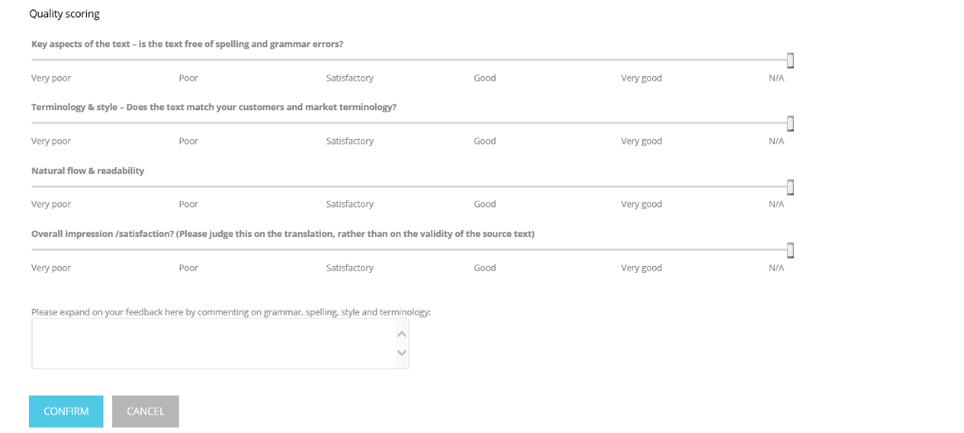  In-depth scoring matrix:  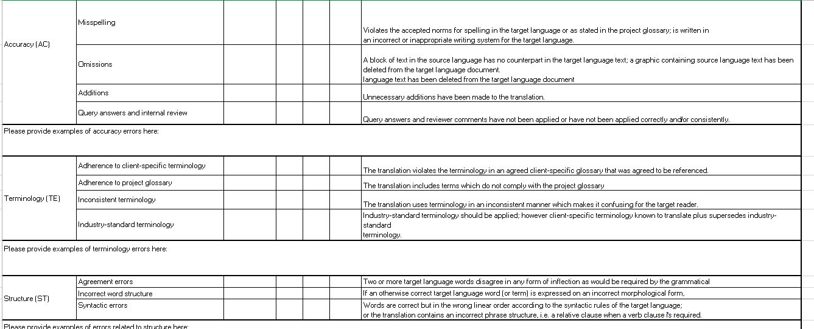
Issue resolution | To come to an agreement with client regarding classification of any issues (minor, moderate, serious, critical) in order to enable an appropriate response.  - Minor issue (one off project-specific issue) to be responded to and resolved within 1 business day by Project Manager, Project Director or Account Manager  - Moderate issue (a more general issue, but which is not significantly impacting overall quality and/or timings and is not causing issue with client) to be responded to and resolved within 2 working days by Project Manager, Project Director or Account Manager  - Serious issues (a general and/or repeated issue, which has been raised by client, and/or is seriously affecting quality/timings and which must be prioritised immediately) to be responded to and resolved within 3 working days by Project Director or Account Manager  - Critical issues (a business critical issue which is of severe threat to client) to be responded to within 1 working day and resolved within 5 working days by Project Director, Account Manager or their superiors  If an issue occurs which requires more time for further detailed investigation by translate plus, translate plus shall notify client immediately to discuss an agreed deadline for resolution.
Archive | Client will send all source files for every job request, including updates of previous jobs, art files, etc. translate plus will keep copies of source files and translated files until client requests that the files are to be deleted or the agreement between translate plus and client is terminated. This may not apply to the storage of large multimedia files, which require additional server space.
Adaptability | Client may look to change its existing processes for obtaining translation services. Changes will be shared and agreed with translate plus. translate plus will monitor processes and make recommendations for change for continuous improvement as part of our commitment to quality.
Translation memory updates | translate plus to ensure client’s translation memories are systematically updated and maintained after client’s copy approval (unless agreed otherwise) to ensure quality and consistency in content.

